Airspace restrictions

The G7 event taking place in Cornwall in June 2021 will be attended by significant world leaders and delegates and will involve a complex logistical and security operation. There are multiple associated venues and so the airspace operation is not limited solely to the Carbis Bay/St Ives area.

Significant temporary airspace restrictions will be put in place during the preparation and operational phases. These will take place between 7-13 June 2021. Full details of the restrictions will be published within an Aeronautical Information Circular.

Any unauthorised flight into or within this Restricted Airspace is forbidden. This applies to all aircraft (including drones, remotely controlled aircraft, and un-powered platforms such as paragliders, paramotors and hot air balloons).

Devon & Cornwall Police recognise the significant impact and inconvenience this will have and so have been working with national and local stakeholders to try and keep this to a minimum. However, some impact and inconvenience is regretfully unavoidable.

A permissive process will be in place for those wishing to fly within the boundaries of the RA(T) whilst it is in place. This applies to all aircraft (including drones, remotely controlled aircraft, and un-powered platforms such as paragliders, paramotors and hot air balloons).

Anyone wishing to request permission must submit the associated application form no later than 24 hours before their requested flight time. The attached form should be sent by email to g7airspace@devonandcornwall.pnn.police.uk

The necessity of all applications will be considered robustly, so other options should be explored where possible. The permissive process will be based on recognised air traffic control flight priority categories as detailed within CAA Supplementary Instruction (SI) CAP 493 MATS Part 1.

Temporary Restricted Airspace: St Ives
Start: Sunday 6 June 2021
Finish: Wednesday 9 June 2021 (note: wider restriction follows this)
Surface: 3,000ft
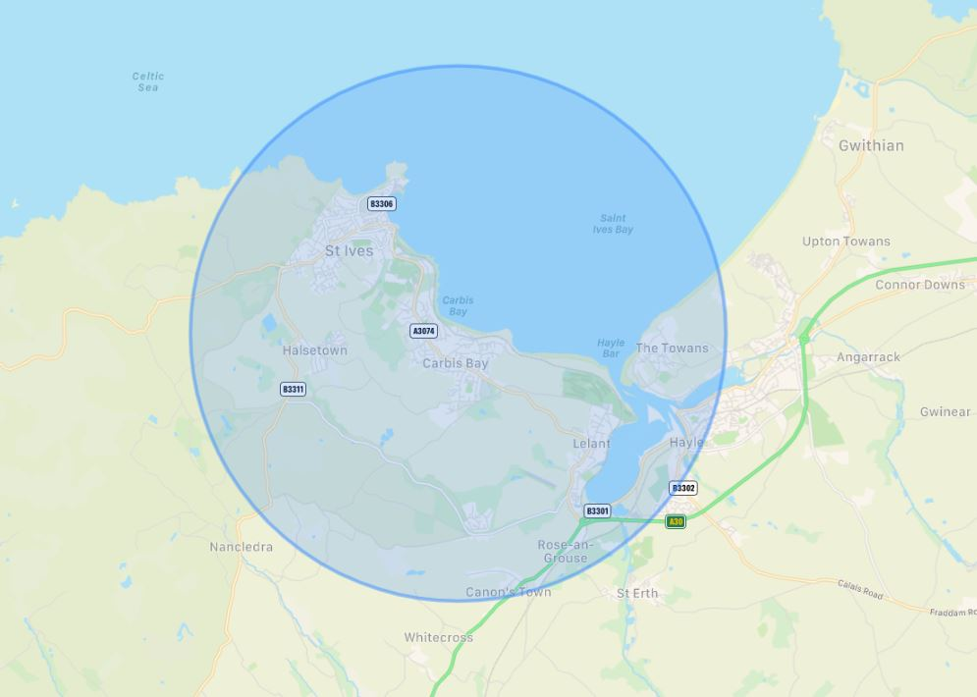

Temporary Restricted Airspace: Cornwall
Start: Wednesday 9 June 2021
Finish: Sunday 13 June 2021
Surface: 10,000ft

